|  |  |
| --- | --- |
| Course Name | ITD 2313 – Script Programming |
| Instructor | Michael Schnell |
| Student Name | Joshua Crow |
| Due date | 10/04/2020 |
| Grade | <grade earned here> |
| Grading Comments | <instructor comments here> |

# Page 62

## Project # 2

### Special Instructions:

1. This project is to be done in a python program file. The file needs to be submitted as part of the submission for this assignment. Place the program file into the zip file that is submitted for this assignment.

* Specific Test data:
* For your test data, use 5 as the side for the first cube you run the program for.  The result should be 150.  For the second run, use a decimal number between 7.129 and 7.999.
* 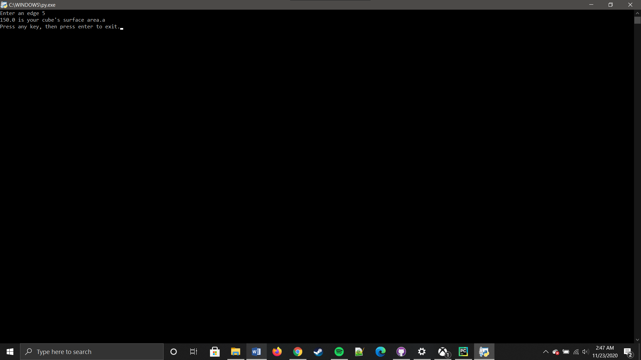
* 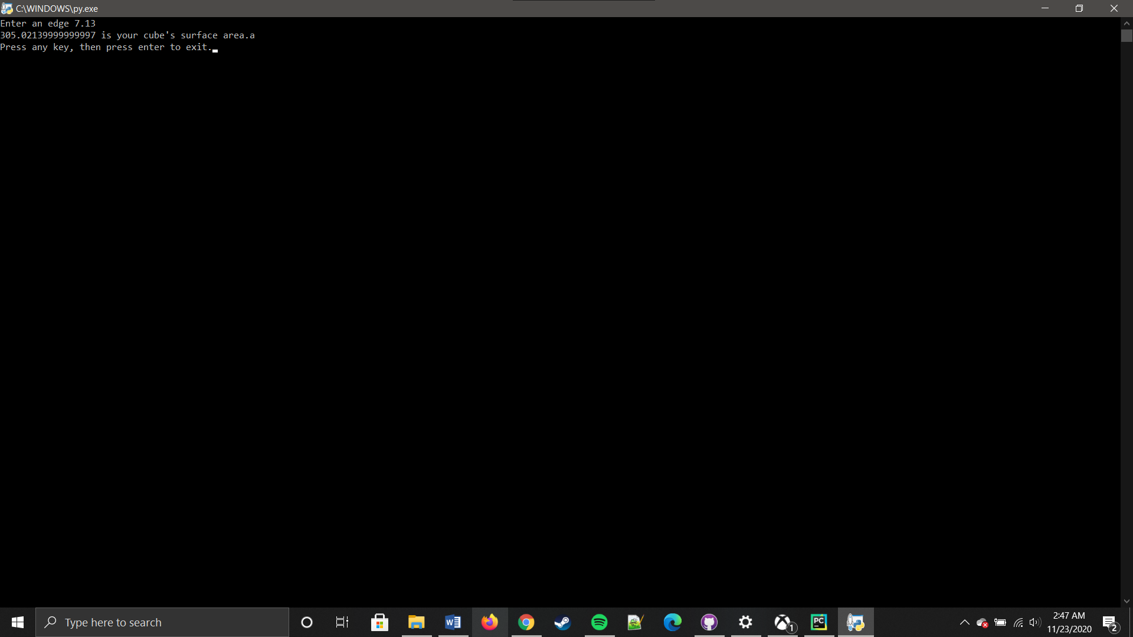

## Project # 3

### Special Instructions:

1. This project is to be done in a python program file. The file needs to be submitted as part of the submission for this assignment. Place the program file into the zip file that is submitted for this assignment.

## Project # 5

### Special Instructions:

1. This project is to be done in a python program file. The file needs to be submitted as part of the submission for this assignment. Place the program file into the zip file that is submitted for this assignment.

You have made it to the end of this projects assignment.  The screen shots you took should be in the Submission document.  Any and all code written will need to part of the overall submission to the drop box. Place all code and the submission document into a single ZIP file and submit that zip file to the dropbox.